To: | City Executive Board
Date: | 9 February 2017
Report of: | The Service Manager, Environmental Sustainability
Title of Report: | Refresh of Carbon Management Plan: 2017/18 - 2021/22

Summary and recommendations
Purpose of report: |  | The current five year phase of the Council’s Carbon Management Plan (CMP) concludes at the end of March 2017. The purpose of this report is to approve the next five year phase of the CMP (2017-2022).
Key decision: |  | Yes
Executive Board Member: |  | Cllr John Tanner, A Clean, Green Oxford
Corporate Priority: |  | A Clean, Green Oxford.
Policy Framework: |  | Sustainability Strategy
Recommendations: That the City Executive Board resolves to:
1. | Adopt the new Carbon Management Plan as detailed in Appendix 1;
2. | Note that now straight-forward and accessible carbon reduction measures have been implemented through use of the Salix and Salix Plus funds, there will be the need to make financial bids for external support for larger capital projects, additional match funding requests or innovative approaches of using community funding models with shared financial advantages;
3. | Endorse the phased development of an Energy Management system (ISO 50001) over the next 5 years across all key significant energy use areas at the Council (e.g. Offices, Depots, Leisure Centres, Fleet fuel consumption);

Appendices
Appendix 1 | Carbon Management Plan 3: Continual improvement in carbon and cost reduction – The Oxford City Council Carbon Management Plan 2017-2022
Appendix 2 | Risk Register

Introduction and background

- Oxford City Council has successfully rolled out phases of its Carbon Management Plan since 2008/09, implementing measures calculated to reduce CO₂ emissions by over 5000tCO₂ per year by 2015/16, reducing utility bills and playing its part in tackling climate change and offering leadership to other organisations. The first phase was called “Getting our House in Order”, the second phase “Carbon Reduction at the Heart of Everything we do”. The third phase “Continual improvement in carbon and cost reduction” is due to start in April 2017.

- The carbon emissions reductions to date have been achieved through a range of measures such as LED lighting and controls upgrades, boiler upgrades, reduction of waste to landfill, fleet fuel reduction measures, estates rationalisation and building disposals, as well as significant deployment of renewable energy technologies. The Council is now producing over 750,000kWh of electricity per year (or the equivalent of 8% of its electricity demand) through Solar PV installations on the roof tops of its buildings.

- Reducing CO₂ emissions leads to significant reductions in the associated energy, water and fuel spend. It is estimated that the Council is now spending approximately £500,000 less per year on these bills than it would have been spending at consumption levels prior to proactively targeting CO₂ emissions reductions across its estate and operations.

- To compare performance now with that of the original baseline period (2005/06) given expansion of scope over time, we can broadly estimate that our carbon footprint would have been about 42% larger (14,070tCO₂) under a business as usual scenario.

- Our actual emissions at end of 15/16 are expected to be c.9040tCO2 – which equates to an absolute decrease of 25% over the period 2005/06 to 2016/17.This is presented simplistically in Figure 1.

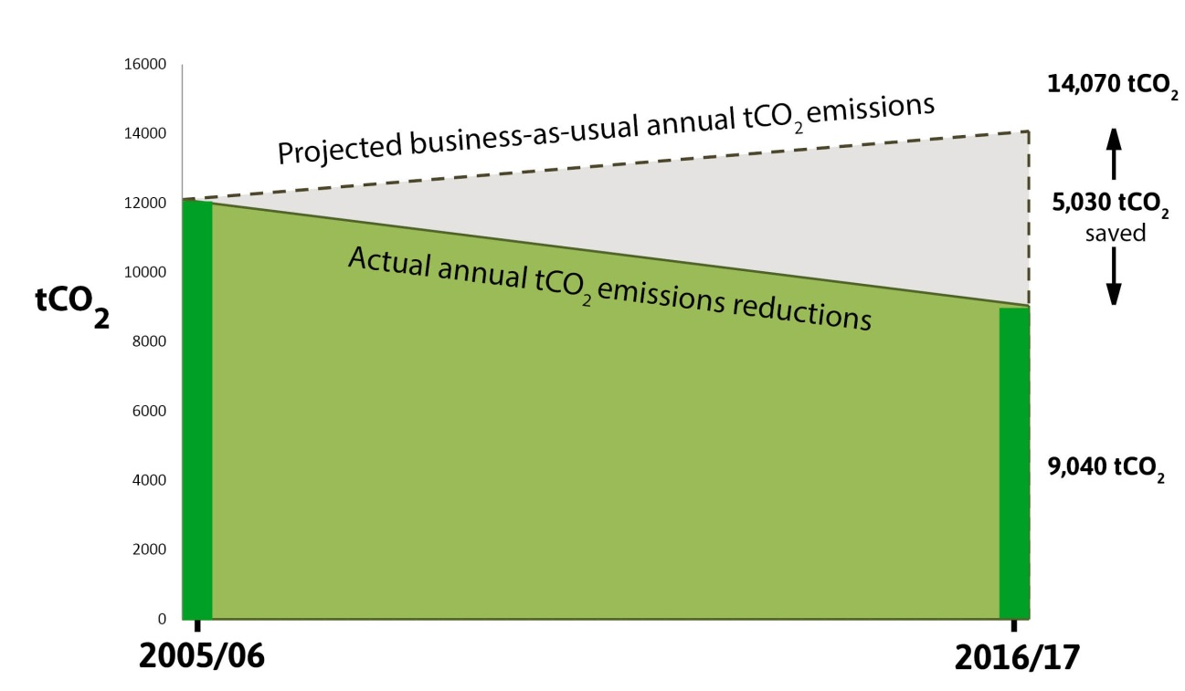
Figure 1: Emissions reductions compared to business-as –usual scenario

- The 25% reduction in absolute emissions has been achieved against an upward pressure on carbon emissions from increased leisure centre user numbers (going up by approximately 7% over the last 3 years), increased recycling (extra vehicle movements) and commercial activity that has a direct impact on Council energy, fuel and water use.

- A refreshed and updated plan covering the next 5 years (2017/18 to 2021/22) has been developed to ensure continual improvement in carbon and energy management, driving down energy, fuel and water spend and their associated carbon dioxide emissions. The aim is to deliver significant progress against the current corporate carbon target of minimum 5%/year reduction by implemented measures (See Appendix 1). If successful, it is estimated that this will yield a 2044 tCO₂/year reduction in CO₂ emissions through implemented measures and an estimated cash saving of over £100k per year when compared with business-as-usual operation. It is anticipated that extra investment will be needed to achieve these targets (see Financial implications section below).

- Given that many relatively straight-forward carbon reduction measures have been installed in recent years through efficient use of revolving loan funds and estate rationalisation, continuing to meet the 5%/year target will be increasingly challenging. Significant progress will be delivered by the development of more formal procedures and awareness of energy management responsibilities of all staff that have direct control or influence over energy, fuel and water consumption. This can be facilitated through the development and roll out of council-wide Energy Management Systems such as those in ISO 50001.

- The “Continual improvement..” theme underpinning the new CMP phase means seeking out all opportunities across the Council to reduce carbon emissions and energy, fuel and water spend; using the expertise of staff in their immediate work area to spot new opportunities making sure all new technological advances are tracked and deployed when cost effective. Engagement across the Council is vital to identifying new opportunities.

- Crucial to developing these opportunities and getting close to the target over the 5 year period is securing further funding for their implementation. Particular emphasis needs to be placed on the decarbonisation of heat and leisure centres. Typically these initiatives involve high capital cost plant, resulting in running cost and carbon reduction over the life of the plant. Funding will be sought from government and via internal budget bids during this phase of the plan. Bids for external funding support will be made as required for large scale capital projects to drive down carbon emissions. Given the more complex nature of larger scale projects, progress is likely to be challenging with longer lead in times to realise carbon reductions. Robust and detailed business plans for significant additional match funding requests will be required with all key staff expected to support their development. Innovative funding models will be also considered where appropriate using community share offer funding models such as those developed by the Low Carbon Hub.

Achievements to date

- The Council has achieved acclaim for its successes and achievements to date in the area of carbon management over the years that it has been implementing its carbon management plans. This has led to a series of knock-on benefits attracting significant funds into the City and boosting activities in the City-wide approach to CO₂ emissions reduction. Since 2008 the Council has achieved the following:

- Significantly increased the number of Solar PV installations across the City – now generating over 750,000kWh/year of clean energy – generating the equivalent of over 8% of the Council’s electricity requirements through Solar PV by 2015/16
- Signing up to the Covenant of Mayors to work with hundreds of other Cities around the world to reduce CO₂ emissions (http://www.covenantofmayors.eu/index_en.html)
- Recognition for the Council’s carbon management reporting approach of calculating CO₂ emissions through installed measures endorsed as best practice through an independent audit carried out by Price Waterhouse Coopers Ltd (2014/15). Invited to PWC’s Building Public Trust Awards 2015 as a shortlisted organisation (competing against other public and private sector organisations) and cited in their guidance document.
- Local Authority Partner of the Year: Community Energy Awards 2014 for its work in supporting city-wide deployment of community renewable energy schemes
- Continued to win significant match funding to build on its internal revolving Salix fund, winning an additional £100k of match funding on top of the £205k originally secured in 2009 to implement low carbon technologies across the Council. The size of the revolving loan fund is now £605k. The Council has also developed its own innovative revolving loan fund (Salix Plus) that opens up options to fund longer payback energy efficiency projects such as renewable energy technologies as well as fleet fuel and water efficiency projects.
- Launched and developed the innovative Low Carbon Oxford initiative – bringing together key “pathfinder” organisations in the City to reduce the Carbon footprint of Oxford
- One of 9 leading Local Authority (LA) areas in the UK invited to take part in the Department of Energy and Climate Change (DECC) sponsored Low Carbon Frameworks project (leading to winning nearly £360k of additional funding which has helped kick-start Oxford low carbon communities projects and Low Carbon Oxford initiative)
- “Highly Commended” in the Low Carbon Council category of the Local Government Chronicle awards 2011/12)
- the first local authority to achieve the Energy Reduction Verification British Standards Kitemark in 2011

- In order to measure progress in CO₂ emissions reductions against competing drivers like commercial activity levels, numbers of visitors to its leisure centres, and other driving factors that create upward pressure on CO₂ emissions, the Council will continue to monitor and report progress with its carbon management plan through the implementation of measures calculated to reduce CO₂ emissions by 5% each year. The Council will also continue to monitor and report absolute tCO₂ emissions (and “tCO₂ equivalent” covering a wider range of Greenhouse Gas emissions) to Government each year.

- The revised Carbon Management Plan (“Continual improvement in carbon and cost reduction”) included in Appendix 1 outlines our programme of activity for carbon management over the next 5 years building on the strong platform of achievement to date. It sets out the strategic context and the ‘case for action’, our revised carbon emissions scope and baseline, proposed projects and areas of activity and actions to reduce our emissions, as well as the governance arrangements (and escalation routes) to keep the programme on track.

Scope of emissions covered in the new plan
- The scope of the updated carbon management plan will cover all sites that are the Council’s energy, water and fuel billing responsibility, significant emissions sources within the Council’s operations and where we can use funds to implement energy, water and fuel efficiency measures.

- The revised baseline year emissions for 2016/17 are approximately 9037tCO₂. This means that the first year 5% target will require the Council to put measures in place to reduce CO₂ emissions by 452tCO₂ or more during 2017/18. Over the five years to 2021/22 this will mean implementing carbon reduction measures in excess of 2044tCO₂.

Meeting the 5% year on year target

- The following measures and approaches will be applied towards meeting the target to 2021/22 (this list is not exhaustive but covers key areas of focus):

- Salix and Salix-Plus funded energy efficiency measures in buildings
- Active energy management – monitoring and targeting
- Implementation of ISO 50001: Energy Management systems in its significant energy, fuel and water use areas
- Further estate rationalisation;
- Member, Contractor and Staff energy awareness activities;
- Waste reduction activities;
- Fleet energy reduction measures;
- Renewable energy and low carbon technology installations – such as solar PV and heat pumps;
- Decarbonising heat and leisure centres.

Options appraisal

- A Clean, Green Oxford is one of the Council’s key overarching corporate priorities outlined in the Corporate Plan (2016-2020) recognising that “environmental sustainability is key for the planet, the nation and the city”. The Council’s vision is for a city that is “energy efficient, rich in biodiversity and has a growing resource of fossil-free energy and a demonstrably lower environmental footprint”.
- Continual improvement in carbon reduction and energy management within the City council’s own estate and operations will play a key role in meeting this critical corporate priority and reaching world class performance in energy and carbon management. The council can then demonstrate leadership to other organisations.
- It is therefore considered that there are no viable alternatives to the proposed option outlined in this report and to achieve the targets set.

Environmental Sustainability implications
- The Carbon Management Plan outlines how the Council will achieve its annual CO₂ reduction target, one of the Council’s key corporate priorities under ‘A Clean Green Oxford’. It will provide a framework for the Council to deliver progress against the 5%/year carbon reduction target and contribute towards minimizing the Council’s environmental footprint.
Consultation and communications
- Raising awareness of energy, fuel and water efficiency improvements that the organisation is seeking can lead to all staff being able to make a valuable contribution to year on year CO₂ emissions reduction - tapping their knowledge and expertise in their immediate work area.

- The ISO 50001 Energy Management Systems standard places a strong emphasis on staff and senior management engagement. The standard encourages the development of energy management teams focused on specific energy uses so that a targeted approach, development of specific energy performance indicators and continual improvements can be achieved.

- Regular review meetings with energy management teams and communications to all staff on progress towards meeting targets will all assist with fostering wider engagement in delivering the overall aims of the carbon management plan.

- Stakeholder communications will be carried out to get key messages across more consistently and also to seek ideas and input to shape the development of the Plan and Energy Management System. Key stakeholder workshops will also be held to raise awareness of the carbon management plan and energy management systems approaches and to assist with continual improvement in carbon reduction and energy management.

Financial implications
- The main mechanisms currently in place for funding low carbon technology fixes across the estate in the period to the end of 2021/22 will be the continued use of the Salix £605k revolving loan fund (yielding approximately £100k to £160k available to spend per year) and the ca£200k available from the Salix-Plus fund from 2016/17 (as well as the annual loan repayments from other projects back into this fund – approx. £50k/year).
- Salix is currently only able to be used in buildings and other sites within the estate – where paybacks must, in general, be 5 years. The Salix-Plus fund is an additional internal source of funding to be used in a similar way to Salix – however it provides opportunities for use of funds where Salix is currently not possible e.g. if the paybacks are beyond five years or for use on non-building related energy savings. This could include improvements in fleet technologies or reduction in waste sent to landfill that will lead to reduced carbon emissions.
- Though revolving loans funds have been used successfully to fund carbon reduction measures over the last few years - and this will continue - it is anticipated that the existing resource will not fully fund the implementation of measures to meet the 5% minimum carbon reduction target over the 5 year period of the new plan.
- Additional grant funding bids (with business plans) will be made internally via budget bids, and to government or other available providers as opportunities arise to facilitate continued deployment of renewable energy technologies and build energy efficiency capacity across the Council and wider city area.

Legal issues
- Whilst there is currently no legal requirement to adopt a carbon management plan, continuing progress in the area of energy and carbon reduction is key to meeting international and national legislative requirements e.g. Climate Change Act 2008, Housing and Planning Act 2016, Heat Networks (Metering and Billing) 2014, UK requirements under the Energy Performance of Buildings Directive (Energy Performance Certificates, Display Energy Certificates), and Government Greenhouse Gas Reporting requirements. The energy and carbon markets are continually changing and developing, having a robust energy and carbon management plan, and associated management systems, in place will develop on-going Council resilience and preparedness to legislative changes in the sector as they develop. It will also help the Council realise future opportunities that arise out of changes in legislation in this area.

Level of risk
- The risks to the Council are failure to deliver the carbon management plan and miss opportunities for continual reduction in energy, fuel and water spend and reduce the overall carbon footprint of the organisation. Other risks highlighted relate to failure to meet the corporate target should, for example, resources available diminish or funding not be won during the course of the implementation phase leading to reputational damage.

- A risk register is attached (see Appendix 2), outlining the potential risks including a risk to the future of the Salix fund if it is not possible to implement projects at the required rate of spend by the Salix administration. (Potentially having to return the £300k match fund won since 2008 that has assisted us in meeting our CO₂ reduction targets to date.)

Equalities impact
- Energy management and reducing the Council’s carbon emissions is the responsibility of all Members, staff and contractors at the Council. In terms of an Equalities Impact Assessment, there are no adverse impacts on any part of the community; however Oxford City Council is mindful of the important leadership role it plays across its communities. Energy costs have a disproportionate effect on those on the lowest incomes so it is vital that the Council communicates clearly the reasons for managing energy and reducing carbon emissions.
- The aims and progress of the Council’s carbon management activities are communicated regularly to staff, citizens, community groups and businesses through various media such as the intranet, Internet (Twitter and Facebook), Your Oxford, regular press releases and through the Council’s lead role in the Low Carbon Oxford and related initiatives (e.g. the Low Carbon Hub and the Sustainable Energy Action Plan). Best practice and information on low carbon approaches from the Council’s experience in delivering its carbon management plan are shared regularly with a range of stakeholders through these approaches.

Staff implications
- Continuing to meet year on year carbon reduction targets, and continual improvement in energy, fuel and water management, will become increasingly challenging as the time goes on. They will also need to be achieved against a trend of increased commercial activity and revenue generation and numbers of people visiting our leisure centres, all of which provide upward pressure on carbon emissions and associated spend.
- Current resources within the core delivery team (Energy and Natural Resources team in Environmental Sustainability) will not be able to achieve these targets alone. Full Council-wide engagement with those key individuals and teams that have control and influence over energy, fuel and water consumption will be crucial to delivering progress against the challenging 5%/year target.
- Developing energy management systems processes aligned with the international energy management standard (ISO 50001) will assist with driving wider input and engagement in identifying and reducing unnecessary energy, fuel and water consumption and spend and meeting the challenging year on year targets.

Report author | Paul Spencer
Job title | Energy & Carbon Manager
Service area or department | Environmental Sustainability
Telephone | 01865 252238
e-mail | pspencer@oxford.gov.uk

Background Papers: None

